|  |
| --- |
|  |

**NATIONAL INSTITUTE OF TECHNOLOGY HAMIRPUR, HIMACHAL PRADESH**

SEMINAR REPORT (CH-327)

Topic- The Discovery of the laws governing the impact of an electron upon an atom

SUBMITTED TO- SUBMITTED BY-

DR. TAPAS PALAI MANISH KUMAR

DEPARTMENT- ROLL -20BCH044

CHEMICAL ENGINEERING 3RD YEAR 6TH SEMESTER

TABLE OF CONTENT

1. ABOUT THE AUTHOR………………………………… 3
   1. **THEIR WORK………………………………………..….. 4**
2. INTRODUCTION………………………………………….. 4
   1. **HISTORY BEHIND THE EXPERIMENT………………. 5**
3. Franck–Hertz experiment………………………….. 8
4. Modeling of Electron Collisions With Atoms….. 12

1. CONCLUSION…………………………………………… 14
2. REFERENCE……………………………………………… 14

ABOUT THE AUTHOR

# **The Nobel Prize in Physics 1925**

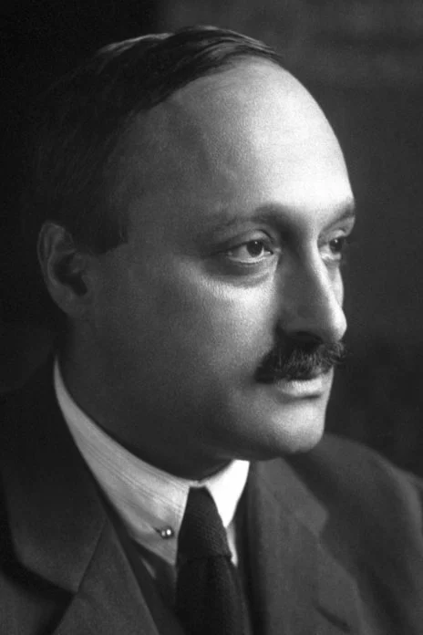

**James Franck**

**The Nobel Prize in Physics 1925**

Born: 26 August 1882, Hamburg, Germany

Died: 21 May 1964, Göttingen, West Germany (now Germany)

Affiliation at the time of the award: Goettingen University, Göttingen, Germany

**Prize motivation: “for their discovery of the laws governing the impact of an electron upon an atom”**

*James Franck received his Nobel Prize one year later, in 1926.*

Prize share: ½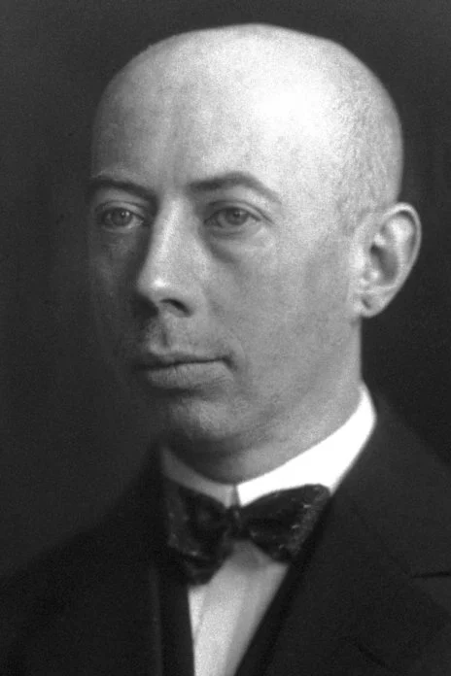

Photo from the Nobel Foundation archive.

**Gustav Ludwig Hertz**

**The Nobel Prize in Physics 1925**

Born: 22 July 1887, Hamburg, Germany

Died: 30 October 1975, Berlin, East Germany (now Germany)

Affiliation at the time of the award: Halle University, Halle, Germany

**Prize motivation: “for their discovery of the laws governing the impact of an electron upon an atom”**

*Gustav Hertz received his Nobel Prize one year later, in 1926.*

Prize share: ½

Photo from the Nobel Foundation archive.

**THEIR WORK**

After the publication of Niels Bohr’s theory on the structure of the atom, Gustav Hertz and James Franck conducted an experiment in 1913 to verify it. A potential difference was applied to a tube containing a low-pressure gas. When the potential difference was increased, the current flowing through the tube also increased until it reached a certain voltage, when it suddenly declined. The result supported Bohr’s theory, in which electrons can only have specific, discrete energies. The potential difference increased the free electrons’ mobility until, at a certain energy level, bound electrons jumped to a higher-energy orbit instead.

INTRODUCTION

From the early spectroscopic work it is clear that atoms emit radiation at discrete frequencies from Bohr’s model, the frequency of the radiation is related to the change of energy levels through E=hv. It is then to be expected that the transfer of energy to atomic electrons by any mechanism should always be in discrete amounts. One such mechanism of energy transfer is through inelastic scattering of low-energy electrons.

Franck and Hertz in 1914 set out to verify these considerations.

(a) It is possible to excite atoms by low-energy electron bombardment.

(b) The energy transferred from electrons to the atoms always had discrete values.

(c) The values so obtained for the energy levels were in agreement with spectroscopic results.

The Franck–Hertz experiment elegantly supports Niels Bohr's model of the atom, with electrons orbiting the nucleus with specific, discrete energies. Franck and Hertz were awarded the Nobel Prize in Physics in 1925 for this work.

**HISTORY BEHIND THE EXPERIMENT**

The newest and most flourishing branch of the great tree of physical research is atomic physics. When **Niels Bohr** founded this new science in 1913, the material at his disposal consisted of data concerning the radiation of glowing bodies, which had been accumulated over several decades. One of the earliest findings in the field of spectroscopy was that the light emitted by a glowing gas when observed through a spectroscope splits up into a large number of different lines, called spectral lines. The fact that simple relationships exist between the wavelengths of these spectral lines, was first discovered by **Balmer** in 1885 for the hydrogen spectrum and demonstrated later by **Rydberg** for a large number of elements. Two questions relating to theoretical physics arose as a result of these discoveries: **How is it possible for a single element to produce a large number of different spectral lines?** And **what is the fundamental reason behind the relationships that exist between the wavelengths of the spectral lines of a single element?** A large number of attempts were made to answer these two questions, on the basis of the physics which we are now accustomed to calling classical physics. All were in vain. It was only through a radical break with classical physics that Bohr was able to resolve the spectroscopic puzzles in 1913. Bohr’s basic hypotheses can be formulated as follows:

Each atom can exist in an unlimited number of different states, the so-called stationary states. Each of these stationary states is characterized by a given energy level. The difference between two such energy levels, divided by Planck’s constant h, is the oscillation frequency of a spectral line that can be emitted by the atom. In addition to these basic hypotheses, Bohr also put forward a number of specific hypotheses, with the aid of which it was possible to calculate the spectral lines of the hydrogen atom and the helium ion. The extraordinarily good agreement with experience obtained in this way, explains why after 1913 almost a whole generation of theoretical and experimental physicists devoted itself to atomic physics and its application in spectroscopy.

For a year now attempts have been made to solve the puzzle of the atom in other ways. But the new theory which is now in process of being established is yet not a completely new theory. On the contrary, it can be termed a further development of Bohr’s theory, because among other things in it Bohr’s basic assumptions remain completely unchanged. In this overthrowing of old ideas, when all that has been gained in the field of atomic physics seemed to be at stake, there is nobody who would have thought it advisable to proceed from the assumption that the atom can exist in different states, each of which is characterized by a given energy level, and that these energy levels govern the spectral lines emitted by the atoms in the way described. The fact that Bohr’s hypotheses of 1913 have succeeded in establishing this, is because they are no longer mere hypotheses but experimentally proved facts. The methods of verifying these hypotheses are the work of James Franck and Gustav Hertz, for which they have been awarded the Physics Nobel Prize in 1925.

Franck and Hertz have opened up a new chapter in physics, viz., the theory of collisions of electrons on the one hand, and of atoms, ions, molecules or groups of molecules on the other. This should not be interpreted as meaning that Franck and Hertz were the first to ask what happens when an electron collides with an atom or a molecule, or that they were the originators of the general method which paved the way for their discoveries and which consists of the study of the passage of a stream of electrons through a gas. The pioneer in this field is Lenard. But Franck and Hertz have developed and refined Lenard’s method so that it has become a tool for studying the structure of atoms, ions, molecules and groups of molecules. By means of this method and not least through the work of Franck and Hertz themselves, a great deal of material has been obtained concerning collisions between electrons and matter of different types. Although this material is important, even more important at the present time is the general finding that Bohr’s hypotheses concerning the different states of the atom and the connexion between these states and radiation have been shown to agree completely with reality.

# Franck–Hertz experiment

# 

|  |
| --- |
| Photograph of a vacuum tube used for the Franck–Hertz experiment in instructional laboratories. There is a droplet of mercury inside the tube, although it is not visible in the photograph. C - cathode assembly; the cathode itself is hot, and glows orange. It emits electrons that pass through the metal mesh grid (G) and are collected as an electric current by the anode (A). |

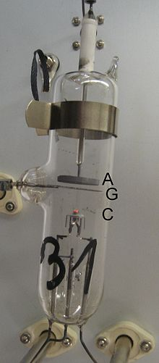Franck and Hertz's original experiment used a heated vacuum tube containing a drop of mercury, they reported a tube temperature of 115 °C, at which the vapor pressure of mercury is about 100 pascals (and far below atmospheric pressure). A contemporary Franck–Hertz tube is shown in the photograph.

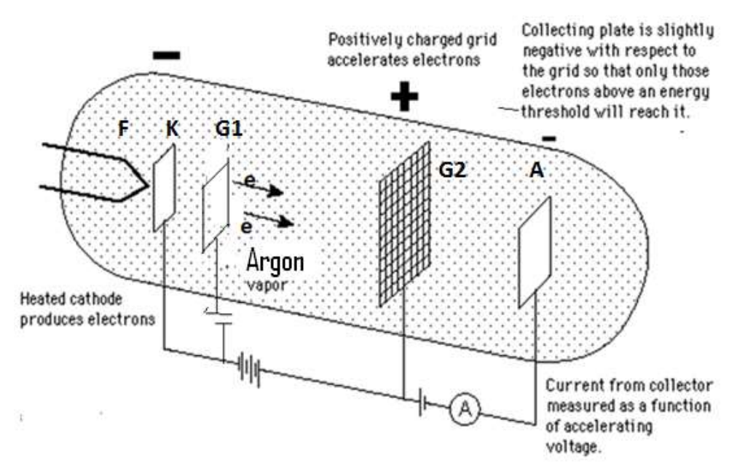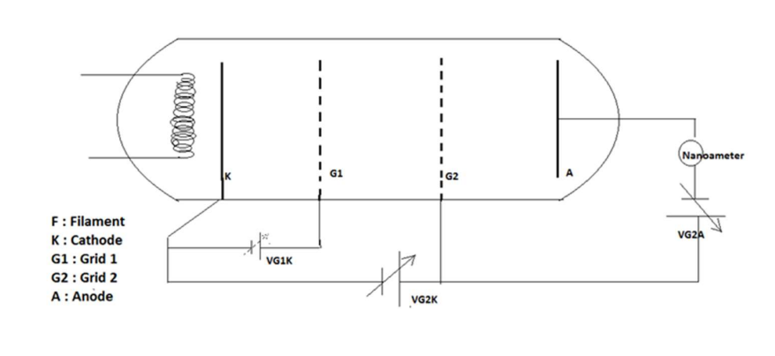

It is fitted with three electrodes: an electron-emitting, a hot cathode, a metal mesh grid, and an anode. The grid's voltage is positive relative to the cathode so that electrons emitted from the hot cathode are drawn to it. The electric current measured in the experiment is due to electrons that pass through the grid and reach the anode. The anode's electric potential is slightly negative relative to the grid so electrons that reach the anode have at least a corresponding amount of kinetic energy after passing the grid.

|  |
| --- |
| Anode current (arbitrary units) versus grid voltage (relative to the cathode). This graph is based on the original 1914 paper by Franck and Hertz. |

The graphs published by Franck and Hertz (see figure) show the dependence of the electric current flowing out of the anode upon the electric potential between the grid and the cathode.

* 1. At low potential differences—up to 4.9 volts—the current through the tube increased steadily with an increasing potential difference. This behavior is typical of true vacuum tubes that don't contain mercury vapor; larger voltages lead to larger "space-charge limited current".
  2. At 4.9 volts the current drops sharply, almost back to zero.
  3. The current then increases steadily once again as the voltage is increased further until 9.8 volts is reached (exactly 4.9+4.9 volts).
  4. At 9.8 volts a similar sharp drop is observed.
  5. While it isn't evident in the original measurements of the figure, this series of dips in current at approximately 4.9-volt increments continue to potentials of at least 70 volts.

Franck and Hertz noted in their first paper that the 4.9 eV characteristic energy of their experiment corresponded well to one of the wavelengths of light emitted by mercury atoms in gas discharges. They were using a quantum relationship between the energy of excitation and the corresponding wavelength of light, which they broadly attributed to Johannes Stark and to Arnold Sommerfeld, it predicts that 4.9 eV corresponds to light with a 254 nm wavelength. The same relationship was also incorporated in Einstein's 1905 photon theory of the photoelectric effect. In a second paper, Franck and Hertz reported the optical emission from their tubes, which emitted light with a single prominent wavelength of 254 nm.

|  |
| --- |
| Wavelengths of light emitted by a mercury vapor discharge and by a Franck–Hertz tube in operation at 10 V. The Franck–Hertz tube primarily emits light with a wavelength near 254 nanometers, the discharge emits light at many wavelengths. Based on the original 1914 figure. |

The figure shows the spectrum of a Franck–Hertz tube, nearly all of the light emitted has a single wavelength. For reference, the figure also shows the spectrum for a mercury gas discharge light, which emits light at several wavelengths besides 254 nm. The figure is based on the original spectra published by Franck and Hertz in 1914. The fact that the Franck–Hertz tube emitted just a single wavelength, corresponding nearly exactly to the voltage period they had measured, was very important.

Modeling of Electron Collisions With Atoms

Franck and Hertz explained their experiment in terms of elastic and inelastic collisions between the electrons and the mercury atoms. Slowly moving electrons collide elastically with the mercury atoms. This means that the direction in which the electron is moving is altered by the collision, but its speed is unchanged. An elastic collision is illustrated in the figure, where the length of the arrow indicates the electron's speed. The mercury atom is unaffected by the collision, mostly because it is about four hundred thousand times more massive than an electron.

|  |
| --- |
| Elastic and inelastic collisions of electrons with mercury atoms. Electrons traveling slowly change direction after elastic collisions, but do not change their speed. Faster electrons lose most of their speed in inelastic collisions. The lost kinetic energy is deposited into the mercury atom. The atom subsequently emits light, and returns to its original state. |

When the speed of the electron exceeds about 1.3 million meters per second, collisions with a mercury atom become inelastic. This speed corresponds to a kinetic energy of 4.9 eV, which is deposited into the mercury atom. As shown in the figure, the electron's speed is reduced, and the mercury atom becomes "excited". A short time later, the 4.9 eV of energy that was deposited into the mercury atom is released as ultraviolet light that has a wavelength of precisely 254 nm. Following light emission, the mercury atom returns to its original, unexcited state.

If electrons emitted from the cathode flew freely until they arrived at the grid, they would acquire kinetic energy that's proportional to the voltage applied to the grid. 1 eV of kinetic energy corresponds to a potential difference of 1 volt between the grid and the cathode. Elastic collisions with the mercury atoms increase the time it takes for an electron to arrive at the grid, but the average kinetic energy of electrons arriving there isn't much affected.

When the grid voltage reaches 4.9 V, electron collisions near the grid become inelastic, and the electrons are greatly slowed. The kinetic energy of a typical electron arriving at the grid is reduced so much that it cannot travel further to reach the anode, whose voltage is set to slightly repel electrons. The current of electrons reaching the anode falls, as seen in the graph. Further increases in the grid voltage restore enough energy to the electrons that suffered inelastic collisions that they can again reach the anode. The current rises again as the grid potential rises beyond 4.9 V. At 9.8 V, the situation changes again. Electrons that have traveled roughly halfway from the cathode to the grid have already acquired enough energy to suffer a first inelastic collision. As they continue slowly towards the grid from the midway point, their kinetic energy builds up again, but as they reach the grid they can suffer a second inelastic collision. Once again, the current to the anode drops. At intervals of 4.9 volts, this process will repeat each time the electrons will undergo one additional inelastic collision.

CONCLUSION

The Franck Hertz experiment consisted of a vacuum tube designed to study the energetic electron that flew through a thin vapor of mercury atoms. It was discovered that only a specific amount of an atom’s kinetic energy would lose as the electron collides with the mercury atom.

For neon gas, the powered electrons excite neon electrons to higher states and further decelerate in a way to provide a glow in the gas region. About ten excited levels can be acquired within the range of 18.3 to 19.5 eV, and they decelerate at a range of 16.57 to 16.79 eV.

REFERENCE

1. J. Franck and G. Hertz, Verhand. Deut. Physik Ges., 16 (1914) 457.
2. G. P. Harnwell and J.J. Livingood, “Experimental Atomic Physics,” McGraw-Hill, New York, 1933.
3. G.F. Hanne, ”What really happens in the Franck-Hertz experiment with mercury,” Am. J. Phys. 56, 696 (1988).
4. D.R.A. McMahon, “Elastic electron-atom collisions in the FranckHertz experiment,” Am. J. Phys. 51 1086 (1983).
5. T.A. Littlefield and N. Thorley, “Atomic and Nuclear Physics,” Van Nostrand, 1968.
6. A.C. Melissinos, “Experiments in Modern Physics,” Academic Press, New York, 1966, Chapter 1, section 3.
7. Stephen T. Thornton and Andrew Rex, “Modern Physics for Scientists and Engineers,” Saunders College Pub., 1993.
8. M. R. Wehr et al., “Physics of the Atom,” 3rd ed., Addison-Wesley, 1978.